Sherwood Forrest Resident’s Association
Minutes from the 2022 Annual General Meeting (AGM)

Date: Wednesday November 9, 2022 @ 7:30pm
Location: Zoom (virtual AGM)
AGM Panelists in Attendance:
- City Councillor for Ward 8 – Matt Mahoney
- MPP for Mississauga-Lakeshore – Rudy Cuzzetto
- Peel Regional Police, 11 Division Officer (Criminal Investigation Bureau) – Sergeant Vertolli
- Carmel Heights Redevelopment Committee (CHRC) Chair – Harry Henderson
- City of Mississauga
  - Hugh Lynch, Manager of Development, Planning and Building Department
  - Brian Bonner, Supervisor of Zoning
  - Costas Nikiforis, Supervisor Building Inspection
  - Max Gill, Supervisor Road Safety
  - Robert Ruggiero, Planner, Planning and Building Department
  - Chris Harding, Supervisor, Compliance and Licensing Enforcement

SFRA Executive for 2022
- President – Bruno Galle
- Vice President – Maria Fernandes
- Treasurer – Soni Sharma
- Secretary – Launa Crasto
- Membership – Alouise Henderson
- Website, Newsletter & Design – Al & Mary Zizek
- City Liaison – Steve Blaney, Pierre Roy
- Sponsorship – Noella Caspersz
- Advertising & Communications – Glenna Gallant
- Events – Cara Cross
This year is not an election year and all existing executive members will stay on for another year to fulfill their two (2) year term (until end of 2023). An election will be forthcoming at the 2023 AGM.
Quorum – AGM Quorum has been met (in accordance with SFRA By-laws), as based on the opinion of the President there is fair representation of members from different households. Note – 80 persons dialed into the AGM.
Recap of 2022 SFRA Events (update provided by SFRA President, Bruno Galle)
Thank you to all the volunteers who helped run the many events we had over the past year and thank you to the volunteers who set up/maintained the ice rink in the park this past winter!
- Open House @ The Pump is next Wed, Nov 16th — we hope you can make it!
- Holiday Festival & Food Drive (Dec 2021) collected $1,213 and 2,000+ lbs of food for Mississauga Food Bank.
- Family Skate (Feb 2022) was back and was the biggest and best in recent memory!
  - Thank you to Councillor Mahoney for covering the cost of the rink liner.
  - Thank you to the many volunteers who maintained the rink
- Easter Egg Hunt (April 2022) was also back in-person and a great success (over 100 kids)!
- Earth Day (April 2022) — great turnout helped clean up the neighbourhood!
- Garage Sale (May 2022) — not as much traffic and participation as in past
- Fun Day (June 2022) – was back on this year with great turnout
- Movie Night in the Park (Sept 2022) — the first of many more, though we need warmer weather
- Halloween Pumpkin Giveaway and Jack-o-Lantern Carving Contest (Oct 2022)
- Little Libraries (still looking for third location!)
- Book Club (year round) and going strong with first Meet the Author event with Elizabeth Renzetti

Communicating with the neighbourhood (update provided by SFRA President, Bruno Galle)
- 4 Newsletters per year were back!
- Email Distribution List - 465 subscribers
- Sherwood Forrest Facebook Group - 482 members
- Website SFRA.ca - averaging 40% more visitors per month compared to 2021

Financial Update (update provided by SFRA Treasurer, Soni Sharma)
Financial information was presented at the AGM, summary as follows:
- Revenue remained consistent year over year
- Our expenses went up as we held our marquee Fun Day event (bouncy castles, bbq, magician, etc) and invested in Movie equipment (projector, screen, etc).
- Overall our balance sheet is in a positive position.
- You can drop off any Membership Dues at Alouise Henderson’s house (2581 Robin Drive) or via e-transfer.
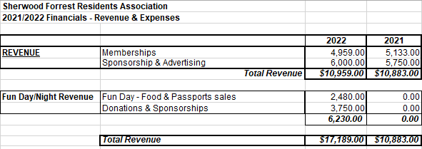

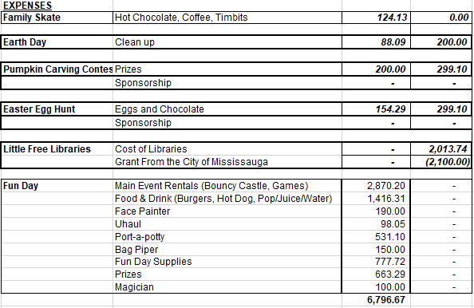
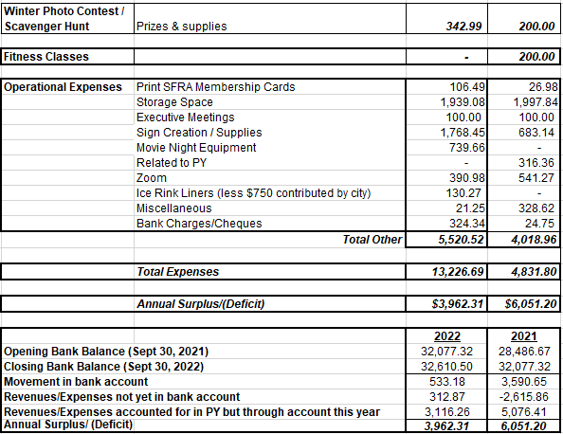
We thank the City of Mississauga for their support via the Community Group Registration Program.

Update from City of Mississauga Councillor, Matt Mahoney (Ward 8)
Updates were provided on a variety of topics which included the following:
- Carmel Heights Redevelopment
  - Applicant told by the city that changes were required. Since then the City has not received a revised application.
- Sheridan Mall Renovations & Future Redevelopment
  - Mall was purchased by Dunpar who has been upgrading the façade of the plaza. Developer is taking a long-term approach. Want to maintain the mall but upscale it, and working on getting more tenants. Planning to keep Metro, plus they have long-term leases with KFC, McDonalds. Plan would be to have mixed-use community (mid rise, townhomes, restaurants/café, plus mall). Councillor Mahoney would like to see a larger stand-alone library on that site. Additional consultation will occur once a more refined plan is developed.
- Hammond House Project Finalized & Approved
  - Initial proposal for 14 townhomes was turned down, they appealed to the OMB and went to a settlement hearing with a final result of 3 single family homes. 1 accessed off of King Forrest, 2 homes accessed off of Hammond Rd. Homes need to be in the character of Hammond House and Sherwood Forrest – ensuring it’s a site that doesn’t look overbuilt.
- Slow Street Program
  - Introduced street signage this year to slow traffic down. Signs vandalized at times and the city had to come back to fix.
  - Pilot programs across the city with other measures that may be able to be utilized here in coming years.
  - Speed limits have been reduced (from 50 to 40) in all residential neighborhoods across the city.
- AirBnB’s
  - Call the police if there are parties. Police have a program too to interact directly with Owners of AirBnBs. City can also work to ensure they have licensing.
  - Reach out to Matt or Rowena Price (Peel Police) for AirBnB issues.
- More Homes Built Faster (Provincial Legislation)
  - New legislation recently passed so the City is currently reviewing the legislation. Deferred to MPP Rudy Cuzzetto to explain community impacts.

Update from MPP for Mississauga Lakeshore, Rudy Cuzzetto
- Redevelopment of Trillium Hospital
- THP is going to be getting a total rebuilt (10 year project). A 32 story hospital to be built.
- Will happen in phases.

- Healthcare Facility in Sherwood Homelands
  - Long term care beds (153) with target to be complete in 2023.
  - Hospice will also be added.

- Mississauga Road / QEW (Credit River) Bridge project
  - A new Twin Bridge will be built to take on the traffic
  - Heritage Bridge will be kept as well.
  - Construction targeted to wrap up by end of 2025.

- Housing & More Homes Built Faster (Provincial Legislation)
  - Shortage of homes (approx. 1.5 million) in GTA, as well as affordable homes
  - Large amount of immigration expected.
  - New Provincial Legislation with 50 action plans.
  - One issue is building density around transit systems/transit hubs to get people out of vehicles (but people often don’t like that). Mississauga has done a good job but other municipalities don’t.

